J A M I E

C H A S T A I N

Photographer

# ABOUT ME CONTACT



Lorem ipsum dolor sit amet, consectetur adipiscing elit. Nunc sit amet sem nec risus egestas accumsan. In enim nunc, tincidunt ut quam eget, luctus sollicitudin neque. Sed leo nisl, semper ac hendrerit a, sollicitudin in arcu.

# WORK EXPERIENCE

 [hello@reallygreatsite.com](mailto:hello@reallygreatsite.com)  +123-456-7890

 123 Anywhere St., Any City

# EDUCATION

## 2017-2020

Fauget

## Photographer

Master of Media and Journalism Wardiere University

2010-2011

Lorem ipsum dolor sit amet, consectetur adipiscing elit. Nunc sit amet sem nec risus egestas accumsan. In enim nunc, tincidunt ut quam eget, luctus sollicitudin neque. Sed leo nisl, semper ac hendrerit a, sollicitudin in arcu.

## 2013-2016

Bachelor of Media and Journalism

Wardiere University

# SKILLS

 Communication

2005-2009

## Borcelle

Photographer

Time management

Lorem ipsum dolor sit amet, consectetur adipiscing elit. Nunc sit amet sem nec risus egestas accumsan. In enim nunc, tincidunt ut quam eget, luctus sollicitudin neque. Sed leo nisl, semper ac hendrerit a, sollicitudin in arcu.

## 2009-2012

 Organization

 Technical skills  Creativity

 Research

# REFERENCES

## Larana, Inc.

Photographer

Adora Montminy / CEO

Lorem ipsum dolor sit amet, consectetur adipiscing elit. Nunc sit amet sem nec risus egestas accumsan. In enim nunc, tincidunt ut quam eget, luctus sollicitudin neque. Sed leo nisl, semper ac hendrerit a, sollicitudin in arcu.

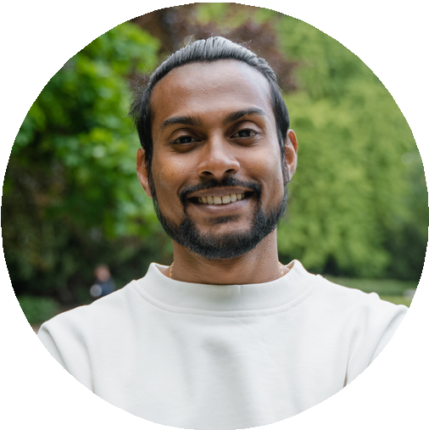

Fauget

Phone: +123-456-7890

Email : [hello@reallygreatsite.com](mailto:hello@reallygreatsite.com)

Claudia Alves / CEO

Borcelle

Phone: +123-456-7890

Email : [hello@reallygreatsite.com](mailto:hello@reallygreatsite.com)