**Product Designer**

A compassionate Family Wellness Counselor with a strong background in providing support and guidance to families facing various challenges.

**EXPERIENCE**

# Studio Showde Canberra - Australia 2020 - 2022

Lorem ipsum dolor sit amet, consectetur adipiscing elit. Vestibulum sit amet quam rhoncus, egestas dui eget, malesuada justo. Ut aliquam augue.

# Elsetown Cor. Kota Baru - Singapore 2016 - 2020

Lorem ipsum dolor sit amet, consectetur adipiscing elit. Vestibulum sit amet quam rhoncus, egestas dui eget, malesuada justo. Ut aliquam augue.

# Studio Showde sydney - Australia 2010 - 2015

Lorem ipsum dolor sit amet, consectetur adipiscing elit. Vestibulum sit amet quam rhoncus, egestas dui eget, malesuada justo. Ut aliquam augue.

**EDUCATION**

# Borcelle University

Bachelor of Business Management 2014-2023

# Borcelle University

Master of Business Management 2014-2018

**SKILLS SUMMARY**

Design Process Project Management

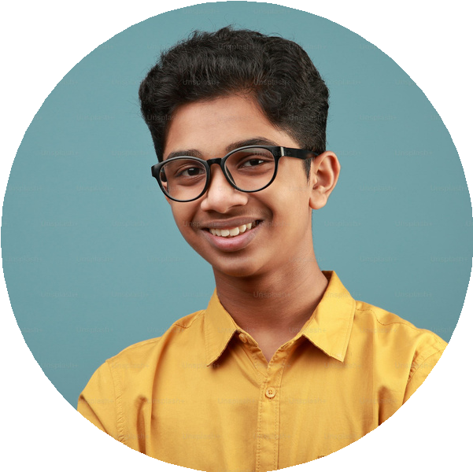

**About Me**

Lorem ipsum dolor sit amet, consectetur adipiscing elit. Vestibulum sit amet quam rhoncus, egestas dui eget, malesuada justo. Ut aliquam augue.

+123-456-7890

[hello@reallygreatsite.com](mailto:hello@reallygreatsite.com) 123 Anywhere St., Any City

English Germany (basic)

Spain (basic)

Management Skills Creativity

Digital Marketing Negotiation Critical Thinking

Leadership

**EXPERTISE**

**LANGUAGE**



78 %

81 %